**Review of projects / applications**

There are variety of different systems that could help influence my application, for example (*Mental Health Foundation*, 2019), (*Mind, the mental health charity*, 2019), (NHS), (Babylon Health, 2016) and (*Healthy London*, 2019), while conducting the research, I have found out that most of the website are using similar layouts, features and contented but they all have different sections for giving information to the users related to their problems and events which include having individual time, date and prices how much it will cost them for the entry. A few websites had Backlink to allow users to view more information about the content they are looking for. I’ve also found that each website had its own personal touch through using the different colour scheme that’s related to their business.

Furthermore, while looking at the Babylon website I have found that the it has a lot of different colour schemes they have used to attract more people and also the website can be accessible from different platform, e.g. mobile phones, laptops. I have also gathered how most sites operates the features that I’m going to implement in my application, e.g. To see if any pop-up messages appear or animations pops up while processing to different stage, which will be a useful tool to use in my application.

**NHS**

NHS is the best site for users to find any information related to their issues and can be used to book an appointment with GPs, Hospitals or any other services they offer form anywhere around the England, similar to the application I’m intending to create but where mine will be accessible from anywhere around the world and can be used by any users over the age of 18. NHS only offers booking if it’s referred by their local GP doctors, where my application does not need any refers form the doctors to book an appointment with a psychiatrist. One of the main features my application will have compare to NHS is users will be able to see psychiatrist availability and choose the time and date they want to see the psychiatrist.

**Pro’s**

* Its free to use and provides contents for users to read
* Its free to book an appointment with doctors or hospital and can be accessed using any device
* Usability, functionality

**Con’s**

* Users have to be registered in order to use the booking system
* Registration can only be done through their local GPS, in order for them to use the website
* User have to be referred by the doctors in order to book an appointment with the hospital

**Figure NHS Application**

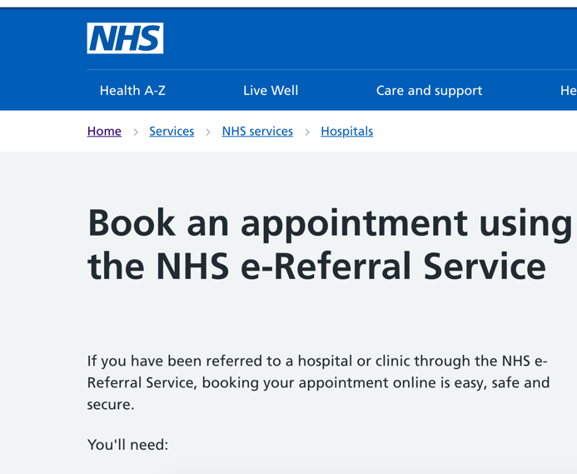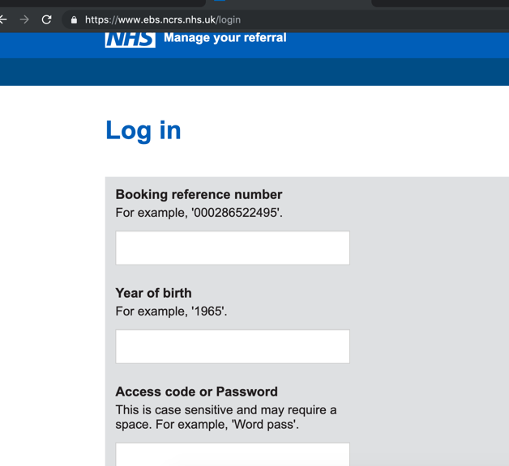

**Babylon**

Babylon is a monthly or yearly subscription health service provider that provides remote consultations with doctors and health care professionals via text message and video messaging through its mobile application. Babylon have similar system to the application I’m intending to create, which allows you to book an appointment with doctors, which requires signing up to the site first. Babylon also offers user friendly interface, dynamic select option and pop up alert which makes the site look more professional.

Pro’s

* User friendly and interactive website
* User can manage their data
* User can pick date and time of the appointment

Con’s

* You have to pay money to use the service
* User will be consulted over Video chat
* The system can face Connection problems
* User won’t be able to reach out to discuss in person

Figure Babylon application

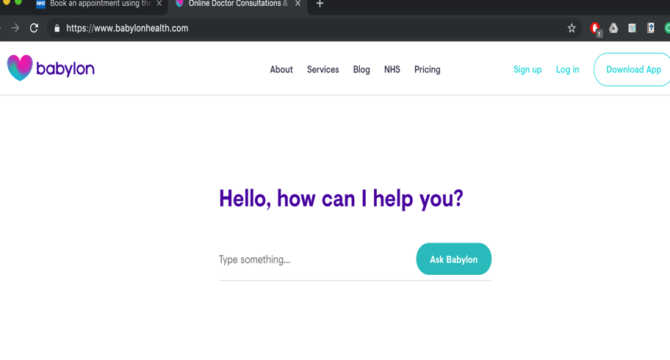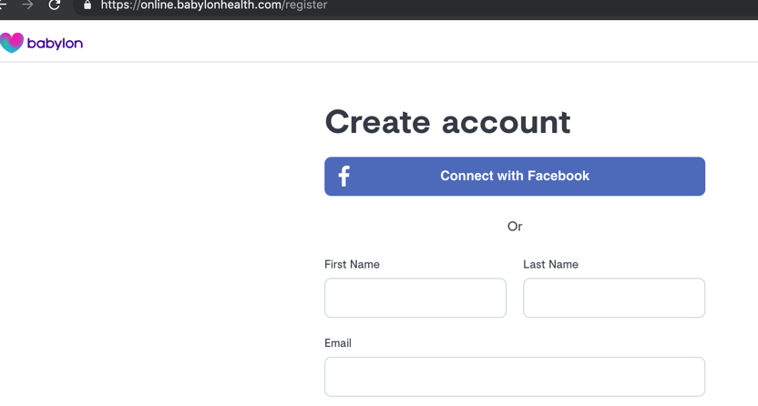

**Feature comparison table**

The table below shows comparison of the proposed system with other system that’s available in the market; as you can see form the tables there are a few features which other system doesn’t offer for users to user, where my application is fully integrated with all the below features.

|  |  |  |  |
| --- | --- | --- | --- |
| Features | NHS | Babylon | My Application |
| Login | **✓** | **✓** | **✓** |
| Registration | **x** | **✓** | **✓** |
| Profile | **x** | **✓** | **✓** |
| Booking | **✓** | **✓** | **✓** |
| Consulting | **✓** | **✓** | **✓** |
| View history | **x** | **✓** | **✓** |
| One to one Live chat | **x** | **x** | **✓** |
| Face to face chat | **✓** | **x** | **✓** |
| Form /Blog | **x** | **x** | **✓** |
| Content page | **✓** | **x** | **✓** |
| Send Emails | **x** | **✓** | **✓** |
| Manage data | **x** | **✓** | **✓** |